Know the signs...

Xbox One - Privacy Guide
Parental controls can be applied to the Microsoft account of each individual child, allowing parents to customise the Xbox One experience for each of their kids. Here is how to get started setting up privacy and safety settings:
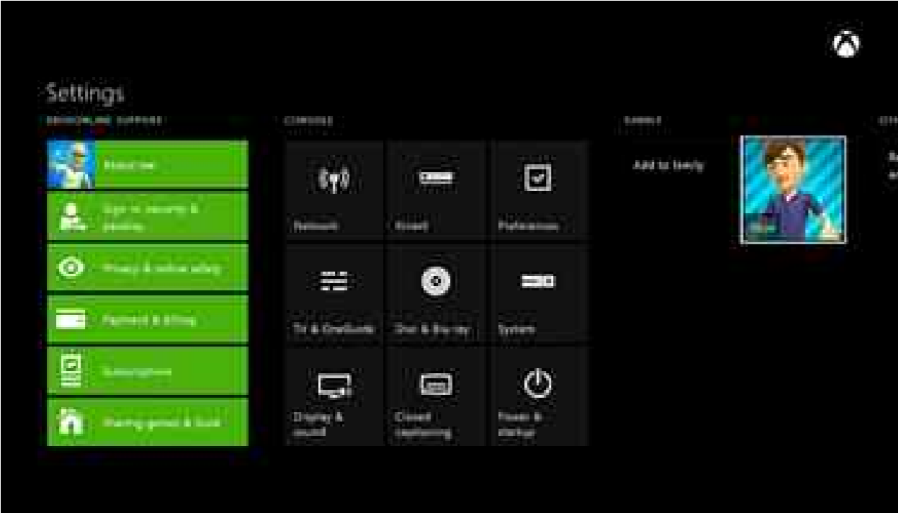
- Sign in to your console
- On your controller, press ‘Menu’
- Select ‘Settings’
- Scroll right to ‘Family’ then select the child profile that you want to modify

View and customise the privacy and online safety settings for your child
After you select your child’s profile, you’re shown the current privacy settings and content restrictions for that child:
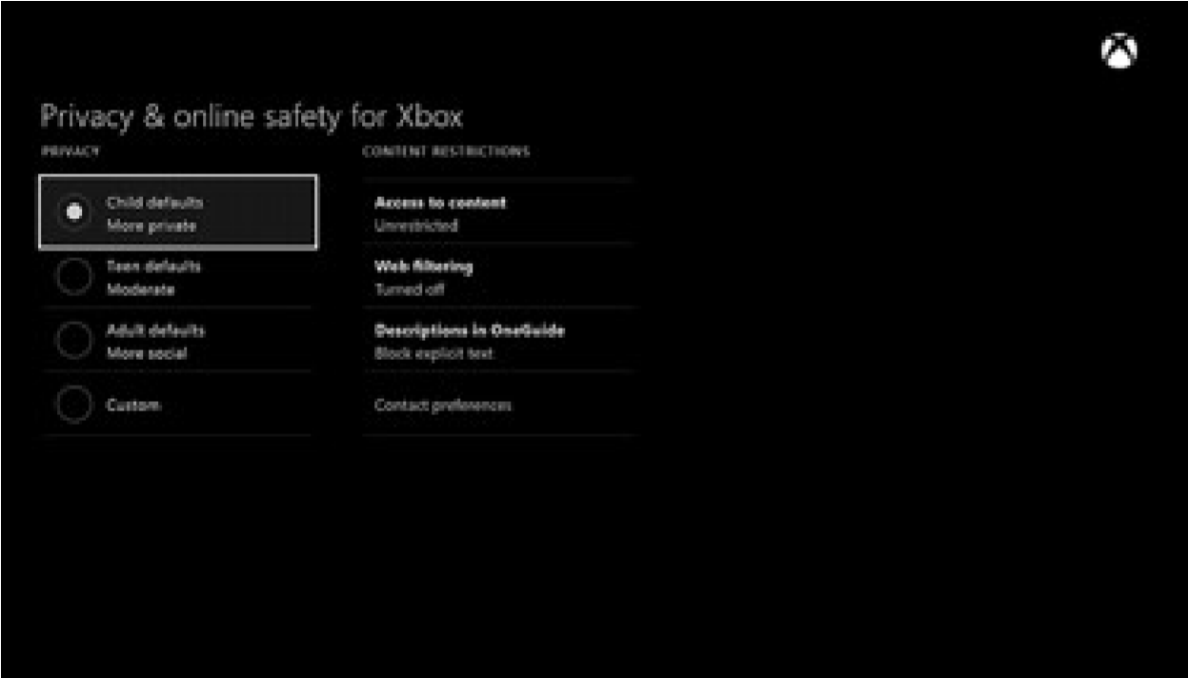
Select any default privacy setting to see its definition. You can keep the default setting or you can customise it.
To customise a setting, select ‘Use, but customise.’
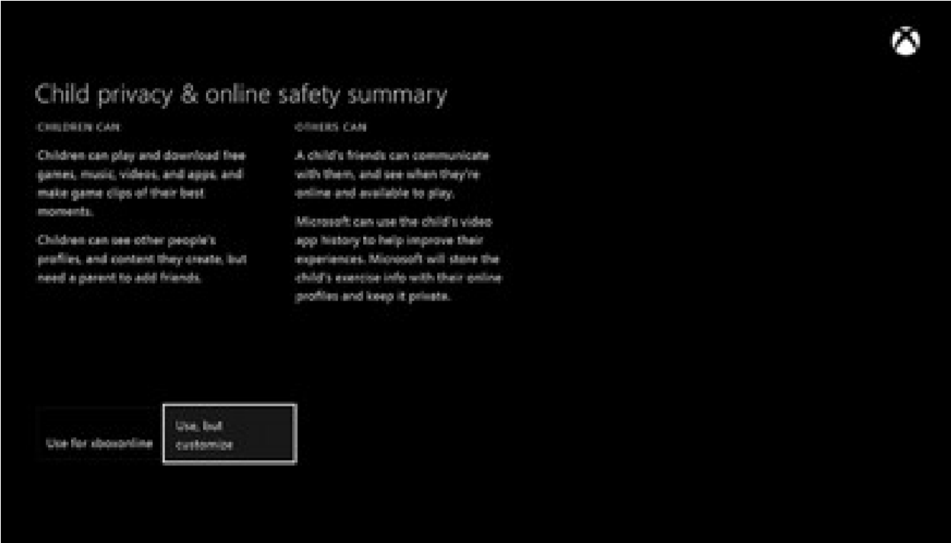
You’re presented with customisation options for each setting. Choose the options that best meet your family's online safety and privacy needs.
Press ‘B’ on your controller to return to the previous screen.

View and customise the content restriction settings for your child
You can manage your child’s content restrictions from the privacy and online safety screen. Content restrictions set parameters for the movies, music, apps, and games your child will have access to.
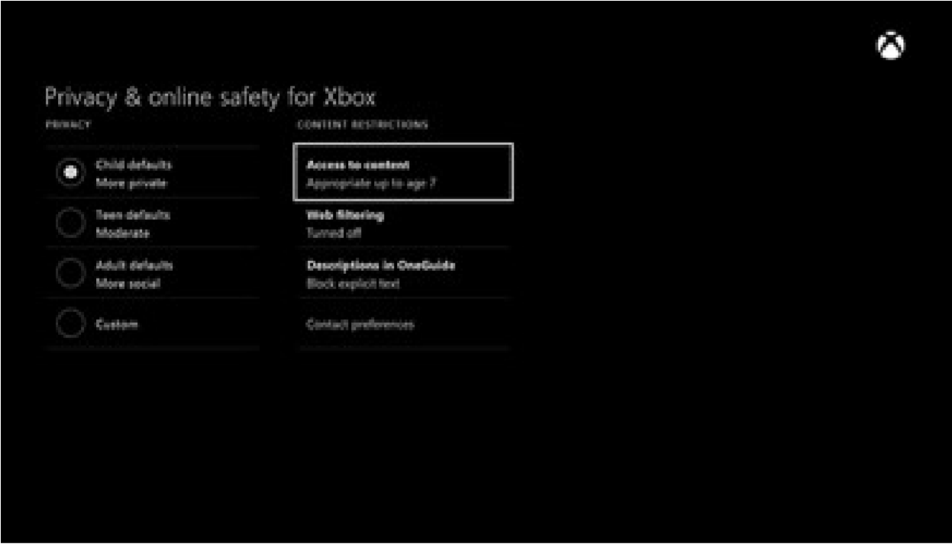
- Select a setting to find out more about it.
- Select ‘Access to content and apps’ to open a menu that will show you the details of your child’s current content restrictions.
- Select the level of restriction that’s appropriate for your child.
Hide listings in search, stores, and apps By default, the level of restriction you set for your child is applied to searches, the store, and apps. To remove this restriction, clear the check box next to ‘Hide listing in

search, stores, & apps.’
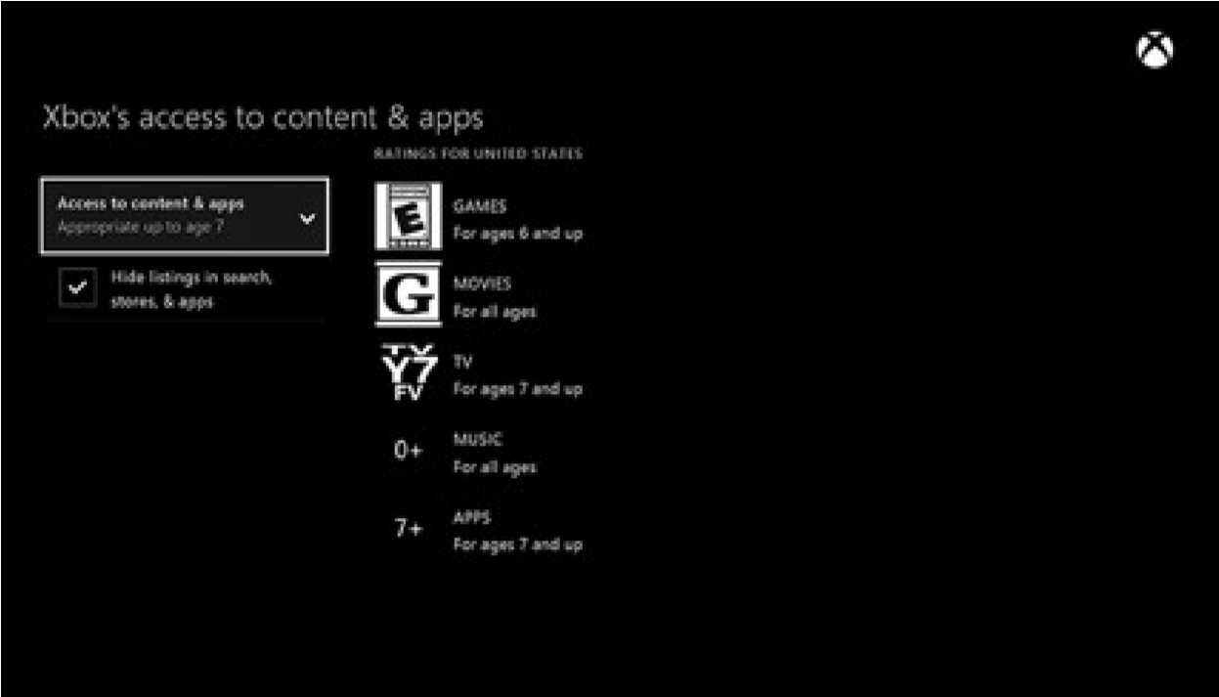
The restriction will be removed for search, stores, and apps, but it will still be applied to actual content. When you’re finished, press ‘B’ on your controller to return to the previous screen.

View and customise the web filtering settings for your child
Web filtering lets you choose the kinds of websites your child can visit using Internet Explorer. To set a web filtering level for your child:
- On your controller, press ‘Menu’
- Select ‘Settings’
- Select your child’s profile
- Under ‘Content Restrictions,’ select ‘Web filtering’ to see a menu that enables you to select the level of filtering that’s appropriate for your child
- When you’re finished, press ‘B’ on your controller to return to the previous screen

Know the Signs
Child sexual exploitation can take place over the internet, and can lead to other ‘off line’ types of CSE.
Even something that seems like normal teenage behaviour could be a sign that a child is being exploited.
These can include:
- Increasing or secretive mobile phone use
- Excessive amount of time online & being secretive about time online
- A significantly older ‘boyfriend’ or ‘friend’ or lots of new friends
- Change in behaviour - becoming aggressive & disruptive or quiet & withdrawn
- Unexplained gifts or new possessions such as clothes, jewellery, mobile phones or money that can’t be accounted for
- Regularly missing from home or school and staying out all night
If you have concerns about a child you know report it to West Yorkshire Police by calling 101. Always call 999 in an emergency.
Deaf, hard of hearing or speech impaired people can use textphone 18001 101. You can call Crimestoppers anonymously on 0800 555 111.

