Snapchat
Snapchat has two privacy settings, each with different options:
Who Can Send Me Snaps - you have two privacy options: "Everyone" and "My Friends."
Who Can View My Story - you have three privacy options: "Everyone,” "My Friends," and “Custom.”

By default, only users you add to your friends list can send you Snaps. If a Snapchatter you haven't added as a friend tries to send you a Snap, you'll receive a notification but will only receive the Snap when you add them to your friends list.

Change who can send me Snaps
Tap the gear icon (Settings) on the upper-right corner of the feed screen.
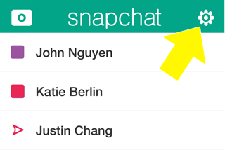
Tap the bar that says “Send Me Snaps."
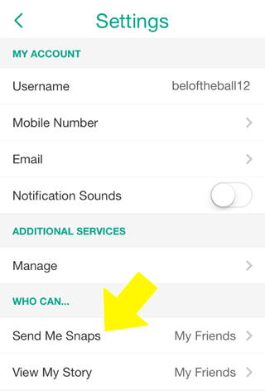
If you want everyone to be able to send you Snaps (even users that you haven't added), tap “Everyone”. If you want just your friends to send you Snaps, tap “My Friends.” Your changes will be saved when you press the back button.
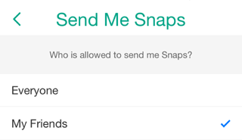

Change who can see my Stories
Tap the bar that says “View My Story."
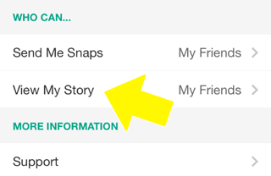
If you want everyone to be able to see your Stories (even users that haven’t added you back), tap “Everyone.” If you want just your added friends to be able to see your Stories, tap “My Friends.” If you want to choose who can view your Stories, tap "Custom" and select which friends you want to block from seeing your Stories. Your changes will be saved when you press the back button.
